7. Import Data from State

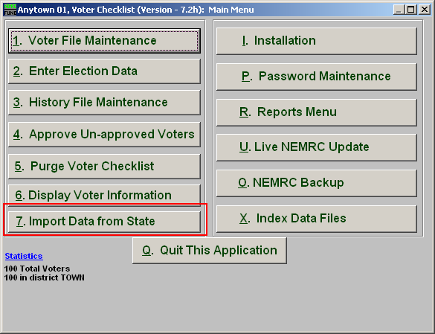
Click on “7. Import Data from State” from the Main Menu and the following window will appear:

Import Data from State

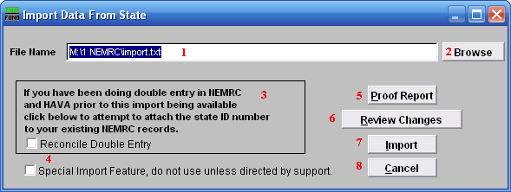
- File Name: Enter the File Name you wish to save the report under.

- Browse: Click on “Browse” to select from other files.

- If you have been doing double entry in NEMRC…: Click on this box if this applies to your situation.

- Special Import Feature: Click on this box ONLY if directed by NEMRC support.

- Proof Report: Click “Proof Report” to print a report.

- Review Changes: Click this box to Review Changes.

- Import: Click “Import” to save on this computer and return to the Main Menu.

- Cancel: Click “Cancel” to cancel and return to the previous screen.

